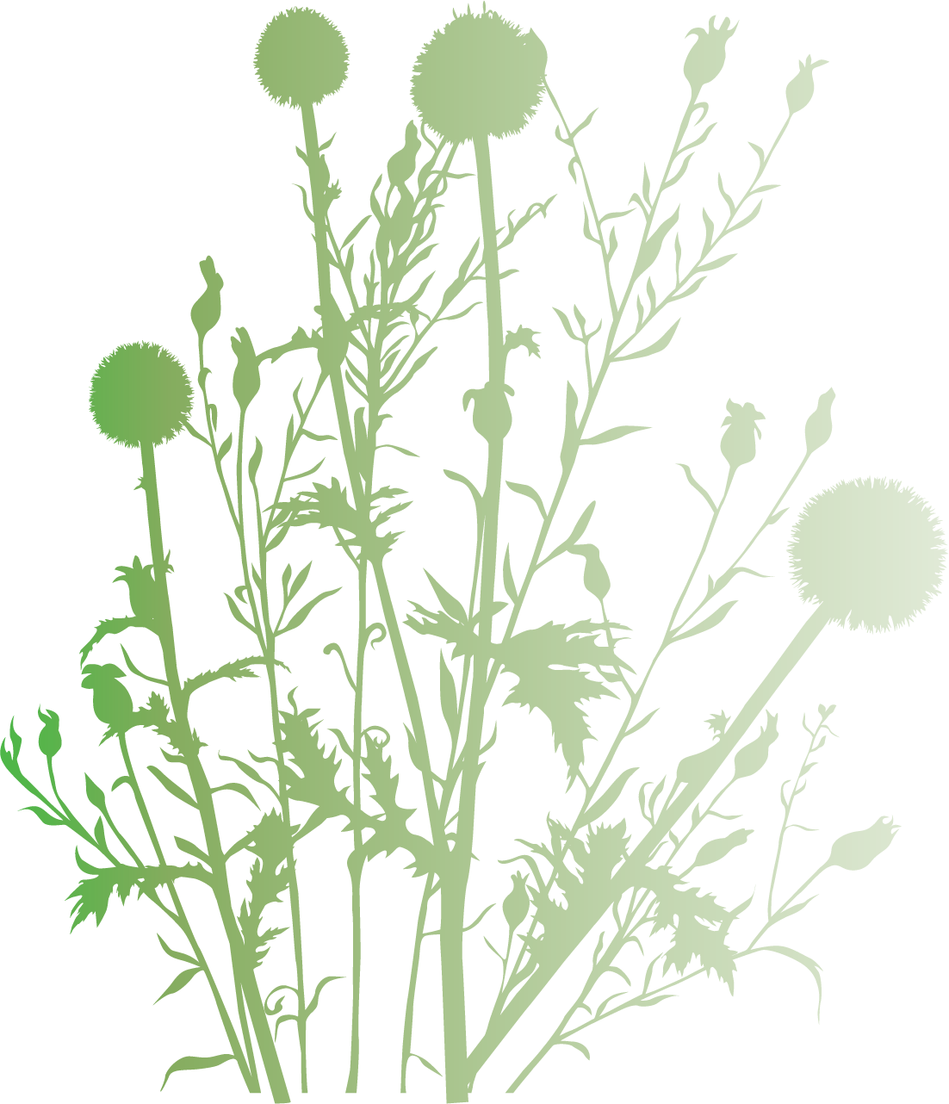

Syllabus

PLS 3223, Plant Propagation

Fall 2024 Online, 2 credits

Instructors |  | Teaching Assistant
Dr. Sandra Wilson  Professor,  Gainesville  (772) 834-7619  sbwilson@ufl.edu | Dr. Mack Thetford  Assoc. Professor  Milton  (850) 983-7130  thetford@ufl.edu | Grace Carapezza  M.S. student  Gainesville  (813) 401-1418  gcarapezza@ufl.edu
LAB INSTRUCTORS AND LOCATIONS: Dr. Mack Thetford (West Florida REC, Milton); Erin Alvarez (Main Campus, Gainesville); Dr. Chris Marble (Mid-Florida REC, Apopka); Dr. Kimberly Klock Moore (Fort Lauderdale REC).

Course Description
The lecture component of this course is completely online. Corresponding labs will be taught on site at the respective campuses. All aspects of plant propagation will be studied that include methods of propagating by seeds, bulbs, divisions, layers, cuttings, budding, grafting, and micropropagation. --Sexual reproduction and seed development will be explored along with seed selection for breeding systems, physiological mechanisms of seed dormancy, and techniques to improve seed production --The timing, technique, and material for making cuttings, environmental conditions, and media requirements for rooting cuttings of ornamental plants, fruit trees, shrubs, and flowering plants will be studied. --Various propagation structures, soils, and fertilizer requirements will be considered. Emphasis is placed on the basic principles of plant propagation to provide an adequate background in the areas of agronomy, horticulture, forestry, and other disciplines of plant science.

Prerequisite
BOT 2010C or BSC 2010

Learning Objectives

At the conclusion of this course, students will be able to:

- Assess how plant physiological reactions, anatomical structures, and environmental influences impact plant propagation.
- Describe the process and steps of various plant propagation techniques.
- Synthesize their knowledge of plant propagation principles and techniques to make informed decisions for diverse industry scenarios.
- Utilize plant propagation terminology and its proper use in oral communication.
- Have a cultivated interest and appreciation of the principles and practices of plant propagation.

Course Materials
CANVAS (for lecture content, additional readings, group assignment descriptions, discussions, testing, etc.) http://elearning.ufl.edu/

website: http://irrecenvhort.ifas.ufl.edu/Propagation/index.html

Course Textbook
Hartmann & Kester's Plant Propagation: Principles and Practices, 9th Edition. 2018. F. Davies, R. Geneve and S.B. Wilson. (Required, ISBN-10 9780134480893; ISBN-13: 978-0134480893).
**Note: There are used desk copies and e-Textbooks available to rent or purchase at a reduced price (see vitalsouce.com; amazon.com and others). Just make sure you get the 9th edition if possible as it is significantly improved!

Other Useful Book References

*desk copies can be found in the instructor’s office

Beyl, C.A. and R.N. Trigiano. 2015. Plant Propagation Concepts and Laboratory Exercises, 2nd edition. CRC Press, Boca Raton, FL.

Dirr, M.A. and C.W. Heuser, Jr. 2006. The Reference Manual of Woody Plant Propagation- From Seed to Tissue Culture, 2nd edition. Timber Press, Inc., Portland, OR.

Kyte, L., J. Kleyn, H. Scoggins and M. Bridgen. 2013. Plants from Test Tubes: An Introduction to Micropropagation, 4th edition. Timber Press Inc., Portland, OR.

Nau, J. (ed.). 2021. Ball Redbook. Volume 2, 19th edition. Ball Publishing, West Chicago, IL.

MacDonald, P.T. 2014. The Manual of Plant Grafting: Practical Techniques for Ornamentals, Vegetables, and Fruit. Timber Press, Portland, OR.

Student Responsibilities
- Attendance: You are expected to watch all lectures and participate activities

- Preparation: You are responsible for retrieving and reviewing necessary materials prior to scheduled zoom discussions

- Exams and assignments: There are no makeups. In the case of emergencies, assignments will be marked down 5 percentage points for each day late.

Student Evaluation
Any questions regarding your performance on any assignment are welcome. Grading follows University standards and will based on the following:

*All assignments are to be submitted via Canvas. Assignments will open on Wednesdays at 11:59 pm and close the following Monday at 11:59 pm. There are 3 required zoom sessions. These are scheduled on the Monday prior to each exam from 5:30-6:30 EST.
Note: although exams and quizzes are open book, students must prepare adequately as these are timed events.

EXAMS (Multiple Choice, T/F, Matching, Short Answer)
Exam 1 (chapters 4-8) 100 pts
Exam 2 (chapters 9-14) 100 pts
Exam 3 (chapters 15-18) 100 pts

ASSIGNMENTS/QUIZZES
Bio/Picture/Video ………5 pts
Pre-course Survey ………5 pts
Quiz 1 (chapters 1-2) ………10 pts
Quiz 2 (chapters 3-6) 10 pts
Quiz 3 (chapters 9-11) 10 pts
Post-course Survey 10 pts
Zoom Participation (3 @ 5 pts for each of the three) 15 pts

Grading Policy
Final grades will be based on the follow scale: 365 Total Points

93.5-100% A 341.3-365.0 pts
89.5-93.4% A- 326.7-341.3 pts
86.5-89.4% B+ 315.7-326.7 pts
82.5-86.4% B 301.1-315.7 pts
79.5-82.4% B- 290.2-300.1 pts
76.5-79.4% C+ 279.2-290.2 pts
72.5-76.4% C 264.6-279.2 pts
69.5-72.4% C- 253.7-264.6 pts
66.5-69.4% D+ 242.7-253.7 pts
62.5-66.4% D 228.1-242.7 pts
59.5-62.4% D- 217.2-228.2 pts
≤59.4% E ≤217.2 pts

Course Schedule

Module | Week | Instructor  Lectures | Guest Lectures and Videos | Reading Assignment & Self Review | E-learning Assignments
1-General Aspects of Propagation | wk 1  Aug 22-27 | How Plant Propagation Evolved in Human Society |  | Read: Chapter 1  Do: Interactive Self-review | Post your Bio  (5 pts)  Take Pre-course Survey  (5 pts)
 | wk 2  Aug 28-Sept 3 | Biology of Plant Propagation | Lecture: D. Clark-  How Genes Impact Plant Propagation (30 min.) | Read: Chapter 2  Do: Interactive Self Review
 | wk 3  Sept 4-10 | The Propagation Environment | Lecture: G. Giacomelli- Greenhouse Systems for Plant Production (102 min.)  Lecture: A. Long – Pathogens in Plant Production (15 min.)  Video: Drs. Wilson and Giacomelli-Environmental Control at Knox Nursery, Winter Garden, FL (11 min.) | Read: Chapter 3  Do: Interactive Self Review  Do: PropG Glossary Term Self Review | Quiz 1:  Chapters 1-2  Timed, open book (10 pts)
2-Seed Propagation | wk 4  Sept 11-17 | Seed Development  Principles and Practices of Seed Selection | Lecture: R. Freyre- Breeding Ornamental Plants (35 min.)  Video: D. Clark-Management and Record Keeping in a Plant Breeding Program (30 min.)  Video: K. Bhattarai- Gerbera Hybridization (9 min.)  Video: G. Cordova- Generating New Triploids in Caladium (8 min.) | Read: Chapters 4 and 5  Do: Interactive Self Reviews
 | wk 5  Sept 18-25 | Techniques of Seed Production and Handling | Lecture: K. Moore -  Plug Production (30 min.) | Read: Chapter 6  Do: Interactive Self Review
 | wk 6  Sept 25-Oct 1 | Principles of Propagation from Seeds | Lecture: B. Geneve-Physical Seed Dormancy (31 min.)  Lecture: X. Li- Seed Priming (18 min.) | Read: Chapter 7  Do: Interactive Self Review | Quiz 2:  Chapters 3-6 Timed, open book (10 pts)
 | wk 7  Oct 2-8 | Techniques of Propagation by Seed | Video: Seedling production at Knox Nursery, Winter Garden, FL (9 min.) | Read: Chapter 8  Do: Interactive Self Review  Do: PropG Glossary Term Self Review | Zoom 1: (5 pts)  Monday Sept 30, 5:30-6:30 pm EST  Review and Discussion with Instructors
3-Vegetative Propagation | wk 8  Oct 9-15 | Principles and Practices of Clonal Selection |  | Read: Chapter 9  Do: Interactive Self Review | Exam 1: Chapters 4-8  Timed, open book (100 pts)
 | wk 9  Oct 16-22 | Principles of Propagation by Cuttings  Techniques of Propagation by Cuttings | Lecture: J. Gibson -  Stock Plant Management, Parts 1 & 2 (43 min.)  Video: P.J. Klinger- Tour of Lake Brantley Plant Co. (15 min.)  Video: F. Davies, M. Thetford & P.J. Klinger-  Lake Brantley Plant Co., Center Hill, FL (22 min.)  Video: G. Griffith- Tour of Hatchett Creek Farms (7 min.)  Video: R. Schoellhorn -  Production scheduling and inventory control at Hatchett Creek Farms, Gainesville, FL (16 min.) | Read: Chapters 10 and 11  Do: Interactive Self Review
 | wk 10  Oct 23-29 | Principles of Grafting and Budding |  | Read: Chapter 12  Do: Interactive Self Review | Quiz 3: Chapters 9-11.  Timed, open book (10 pts)
 | wk 11  Oct 30- Nov 5 | Techniques of Grafting  Techniques of Budding | Video: J. Williamson budding and grafting demonstration of citrus (15 min.) | Read: Chapters 13 and 14  Do: Interactive Self Reviews | Zoom 2: (5 pts)  Monday Nov 4 5:30-6:30 EST  ZOOM Review and Discussion with Instructors
 | wk 12  Nov 6-12 | Layering and Its Natural Modifications |  | Read: Chapter 15  Do: Interactive Self Review  Do: PropG Glossary Term Self Review | Exam 2:  Chapters 9-14  Timed, open book (100 pts)
 | wk 13  Nov 13-19 | Propagation by Specialized Stems and Roots |  | Read: Chapter 16  Do: Interactive Self Review
4-Cell and Tissue Culture Propagation | wk 14  Nov 20-26 | Principles and Techniques of Microprop-agation from Meristematic Tissue | Lecture: M. Kane-  Micropropagation  (1.38 hr lecture)  Video: J. Ginori-Micropropagation Stages  Video: N. Philman-  Sterile technique using a laminar flow hood  (8 min.)  Video: Commercial micropropagation, AgriStarts, Inc., Apopka, FL (15 min.) | Read: Chapter 17  Do: Interactive Self Review | Take Post-course Survey: (10 pts)
 | wk 15  Nov 27-Dec 3 | Principles and Techniques of Plant Tissue Culture from Non-meristematic Tissue | Lecture: W. Vendrame-  Embryogenesis  (20 min.) | Read: Chapter 18  Do: Interactive Self Review  Do: PropG Glossary Term Self Review | Zoom 3: (5 pts)  Monday Dec 2nd 5:30-6:30 EST  ZOOM Review and Discussion with Instructors
FINAL EXAM | wk 16  Dec 4-10 |  |  |  | Exam 3: Chapters 15-18  Timed, open book (100 pts)

Self-review exercises of subject matter for each chapter and glossary terms can be found at http://irrecenvhort.ifas.ufl.edu/creative_tools.html.

UF classes begin August 22nd; withdrawal deadline Nov. 22st, classes end Dec 4th, Reading days Dec. 5-6th, final Exams Dec. 7-13th. Holidays Sept. 2nd, Oct. 18th, Nov. 11th, Nov. 25-26th

Course Policies and Campus Resources

Grades and Grade Points
For information on current UF policies for assigning grade points, see https://catalog.ufl.edu/UGRD/academic-regulations/grades-grading-policies/.

Fees: Distance Learning, $20.00

Attendance and Make-Up Work
Requirements for class attendance and make-up exams, assignments and other work are consistent with university policies that can be found at: https://catalog.ufl.edu/UGRD/academic-regulations/attendance-policies/.

Online Course Evaluation Process
Student assessment of instruction is an important part of efforts to improve teaching and learning. At the end of the semester, students are expected to provide feedback on the quality of instruction in this course using a standard set of university and college criteria. Students are expected to provide professional and respectful feedback on the quality of instruction in this course by completing course evaluations online via GatorEvals. Guidance on how to give feedback in a professional and respectful manner is available at: https://gatorevals.aa.ufl.edu/students/. Students will be notified when the evaluation period opens and can complete evaluations through the email they receive from GatorEvals, in their Canvas course menu under GatorEvals, or via https://ufl.bluera.com/ufl/. Summaries of course evaluation results are available to students at: https://gatorevals.aa.ufl.edu/public-results/.

Academic Honesty
As a student at the University of Florida, you have committed yourself to uphold the Honor Code, which includes the following pledge: “We, the members of the University of Florida community, pledge to hold ourselves and our peers to the highest standards of honesty and integrity.” You are expected to exhibit behavior consistent with this commitment to the UF academic community, and on all work submitted for credit at the University of Florida, the following pledge is either required or implied: "On my honor, I have neither given nor received unauthorized aid in doing this assignment."

It is assumed that you will complete all work independently in each course unless the instructor provides explicit permission for you to collaborate on course tasks (e.g. assignments, papers, quizzes, exams). Furthermore, as part of your obligation to uphold the Honor Code, you should report any condition that facilitates academic misconduct to appropriate personnel. It is your individual responsibility to know and comply with all university policies and procedures regarding academic integrity and the Student Honor Code. Violations of the Honor Code at the University of Florida will not be tolerated. Violations will be reported to the Dean of Students Office for consideration of disciplinary action. For more information regarding the Student Honor Code, please see: http://www.dso.ufl.edu/sccr/process/student-conduct-honor-code.

Software Use
All faculty, staff and students of the university are required and expected to obey the laws and legal agreements governing software use. Failure to do so can lead to monetary damages and/or criminal penalties for the individual violator. Because such violations are also against university policies and rules, disciplinary action will be taken as appropriate.

Services for Students with Disabilities
The Disability Resource Center coordinates the needed accommodations of students with disabilities. This includes registering disabilities, recommending academic accommodations within the classroom, accessing special adaptive computer equipment, providing interpretation services and mediating faculty-student disability related issues. Students requesting classroom accommodation must first register with the Dean of Students Office. The Dean of Students Office will provide documentation to the student who must then provide this documentation to the Instructor when requesting accommodation
0001 Reid Hall, 352-392-8565, https://disability.ufl.edu/

Campus Helping Resources
Students experiencing crises or personal problems that interfere with their general well-being are encouraged to utilize the university’s counseling resources. The Counseling & Wellness Center provides confidential counseling services at no cost for currently enrolled students. Resources are available on campus for students having personal problems or lacking clear career or academic goals, which interfere with their academic performance.

• University Counseling & Wellness Center, 3190 Radio Road, 352-392-1575, www.counseling.ufl.edu

Counseling Services
Groups and Workshops
Outreach and Consultation
Self-Help Library
Wellness Coaching

• U Matter We Care, www.umatter.ufl.edu/

• Career Connections Center, First Floor JWRU, 392-1601, https://career.ufl.edu/.

• Student Success Initiative, http://studentsuccess.ufl.edu.

Student Complaints
• Residential Course: https://sccr.dso.ufl.edu/policies/student-honor-code-student-conduct-code/.
• Online Course: http://www.distance.ufl.edu/student-complaint-process

